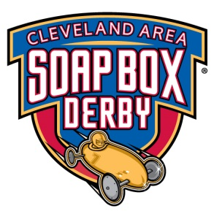
!
March 17th and 18th 2018
IX-Center (Near Hopkins Airport)
Plenty of heat…. and hot rods
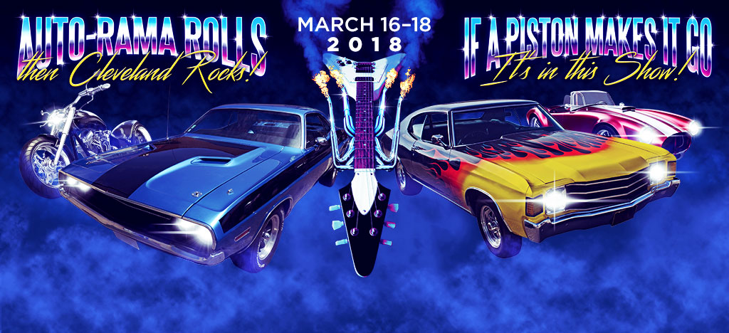
Cleveland Area Soapbox Derby Hosts
All American Soapbox Derby In-Door Race
$35 ea or all 4 for $100 !!*
Space is limited**
In conjunction with:
The Summit Racing Equipment I-X Piston Powered Auto-Rama Presented by Rad Air Complete Car Care and Tire Centers

www.ixpistonpoweredautorama.com

http://clevelandsoapboxderby.com
- One double and one single each day – Stock, Super, Masters
- *Each registered racer will be provided a parking pass, and
extra tickets for their race teams to The 2018 Summit Racing Equipment I-X Piston Powered Auto-Rama Presented by Rad Air Complete Car Care and Tire Centers.
- Purchase extra at the door.
- **Limited number of entrants for this race
- Deadline for registration will be March 4, 2018. A waiting list we be kept for those who do not make the cut off.
- Tickets may not be transferred or sold
- Sat & Sun Registration opens at 7:00 am and closes at 8:00 am
- Scales will be open at 7:30 for official weights. Max 15lb Tail Weight Limit. NO Running Light.
- Building will be open Friday March 17th (3pm to 10 pm) for drop off. Access will be through the Gate 20 of IX center
- Trailers may be left in the adjacent parking lot at the owner’s risk
- Derby cars may be left overnight inside by track. There will be IX Center security present.
- Test runs available for new racers. See race director prior to race
- Concessions will be available through the IX Center. Food and drink may not be brought in
- No animals or alcoholic beverages will be permitted

Mail in Registration or call
CASBD
38567 Misty Meadow Trail
North Ridgeville, OH 44309

Basic Questions >> Contact: Joe Markowski
Email: janssunoco@aol.com Phone: 216-970-6564
You must fill out a registration form to be entered (no voice mails etc). Spots awarded in the order received

AA Indoor Rules apply
Extra Tickets can be purchased at the box office or in advanced at the
www.pistonpowershow.com
- No lighter fluid or cleaning fluid permitted inside IX Center. All wheels must be cleaned outside
- Due to All-American request, emphasis will be on proper footwear. All-American rules state that racers must wear footwear with a sole. Flip-Flops and Socks with tape wrapped around them are not proper footwear.

Discount tickets will be available at:
- Summit Racing Equipment (Tallmadge)
- Northeast Ohio Rad Air locations
- Discount Drug Mart locations.

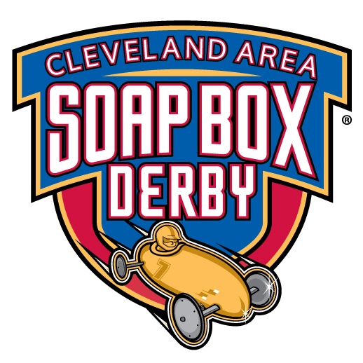

CLEVELAND AREA SOAP BOX DERBY REGISTRATION FORM

PARENTS NAME_________________________________________EMAIL ADDRESS_____________________________

ADDRESS________________________________________CITY________________STATE_____ ZIP CODE___________

PHONE NUMBER________________________________________CELL NUMBER________________________________

TOTAL ADULTS ATTENDING*______TOTAL NON RACERS ATTENDING*(age 7-12)_______(<7)_______

RACERS NAME(S) | DIVISON | SAT. DOUBLE  MARCH 17 | SAT.  SINGLE  MARCH 17 | SUNDAY  DOUBLE  MARCH 18 | SUNDAY  SINGLE  MARCH 18 | AA NUMBER
1.
2.
3.
4.
There will be a limited number of entrants for this race. $35 each race or all 4 for $100. Payment must be sent in with this registration. *Race Teams get free access and free parking; additional entrants must purchase a Piston Power show ticket. Adults $18, children 7-12 $6 and children under 6 are free.

Please send your registration form to:
CLEVELAND AREA SOAP BOX DERBY  38567 MISTY MEADOW TRAIL  NORTH RIDGEVILLE, OH 44039 | derbydyer@oh.rr.com  Please note, if you have a gmail email address please call 440-666-3831, for some reason our Road Runner email does not get along with gmail.
Please call, mail or email this form by no later than March 4th, 2018. If we fill up we will let you know if we need to put you on a waiting list.

Any questions about the race may be directed to Joe Markowski at 216-970-6564 or janssunoco@aol.com.

