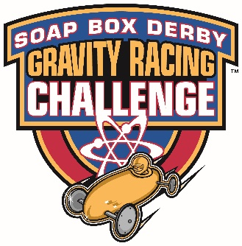
4 p.m. Check-in
- Drivers and Coaches (only) check-in outside of the Hall of Fame and Museum at Topside
5 p.m. Drivers meeting – Hall of Fame and Museum (Blue Building) Topside
- A brief safety meeting will be conducted outside
- After the meeting, drivers will be paired into their first heat and then cars and drivers will be released from top of the hill in racing order.
5:30 p.m. - Racing begins: Super Stock and Open Class
Awards will be presented in the pavilion once the race has finished.
Reminders:
Food, drinks, and tents:
- Students and coaches will be responsible for their own meals.
- A vendor will be located trackside, selling food during the event.
- Teams are permitted to bring 10x10 canopies, chairs, or coolers. These may only be set up in the designated area alongside the track. If tents are set up in the restricted areas, they will be removed.
- Portable restroom facilities are available throughout the grounds: Run-out, starting line, Topside, and at the south end of the grandstands.
- First aid is located at the end of the track in the EMS truck
Suggested items to bring:
- Sunblock,
- Money to purchase food
- Snacks and drinks if they do not wish to buy food at the event
- Tools and extra brake pads
- Team banner to hang trackside
- Team t-shirts
If you have questions, concerns or need general information, the information tent is located trackside near the starting line.

