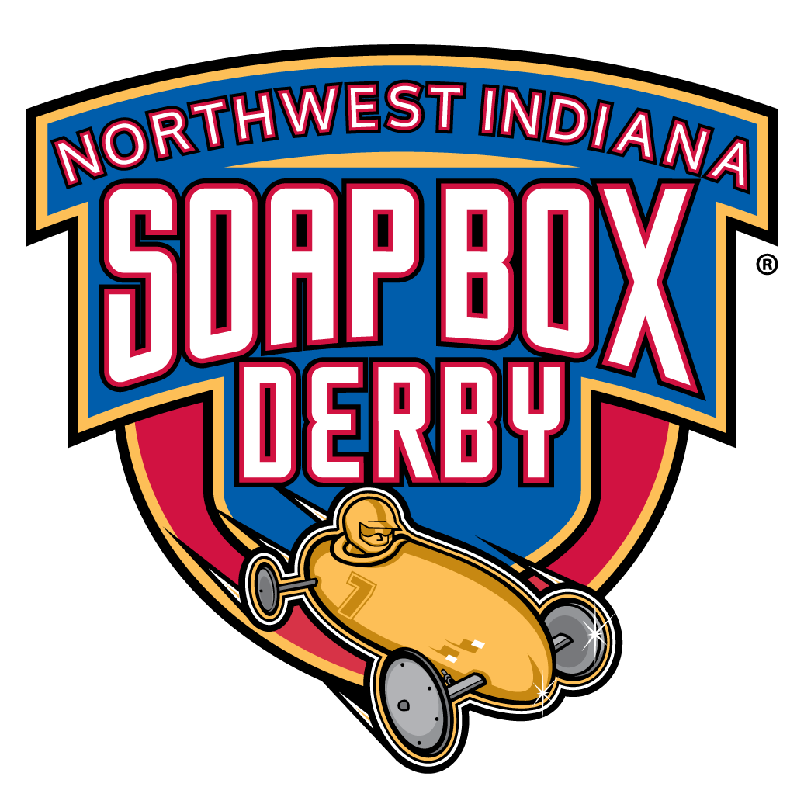
Name of Racer(printed)_________________________________________________
Name of Parent/Guardian(printed)__________________________________________
Signature of Parent/Guardian_________________________________________________

Race Day Shirts
Please indicate which size shirt will be needed. One shirt per participant is included in the entry fee, any additional shirts are $10 each.
ADULT MEN SIZES ONLY
______ Small
______ Medium
______ Large
______ XL
______ 2X
______ 3X

_____________ Total number of shirts

Signage Info for Derby Cars

Type of derby car: Color of derby car
________ Stock
________ Super Stock ________________________________
________ Masters

Signage/sponsors(attach copy of logo/design if needed:_________________________________
_________________________________________________________________________________________________

This form MUST be completed and returned with Race Registration Form.

Updated 3/2019

